**1.Develop Hello Android App.**

**MainActivity.Java**

package edu.sssc.msc1.hellosir;  
  
import androidx.appcompat.app.AppCompatActivity;  
  
import android.os.Bundle;  
  
public class MainActivity extends AppCompatActivity {  
  
 @Override  
 protected void onCreate(Bundle savedInstanceState) {  
 super.onCreate(savedInstanceState);  
 setContentView(R.layout.*activity_main*);

}  
}

**Activity_main.xml**

*<?*xml version="1.0" encoding="utf-8"*?>*<androidx.constraintlayout.widget.ConstraintLayout xmlns:android="http://schemas.android.com/apk/res/android"  
 xmlns:app="http://schemas.android.com/apk/res-auto"  
 xmlns:tools="http://schemas.android.com/tools"  
 android:layout_width="match_parent"  
 android:layout_height="match_parent"  
 tools:context=".MainActivity">  
  
 <TextView  
 android:layout_width="wrap_content"  
 android:layout_height="wrap_content"  
 android:text="Hello World!"  
 app:layout_constraintBottom_toBottomOf="parent"  
 app:layout_constraintEnd_toEndOf="parent"  
 app:layout_constraintStart_toStartOf="parent"  
 app:layout_constraintTop_toTopOf="parent" />  
  
</androidx.constraintlayout.widget.ConstraintLayout>

**Strings.xml**

<resources>  
 <string name="app_name">HELLO ANDROID</string>  
</resources>

**OUTPUT:**

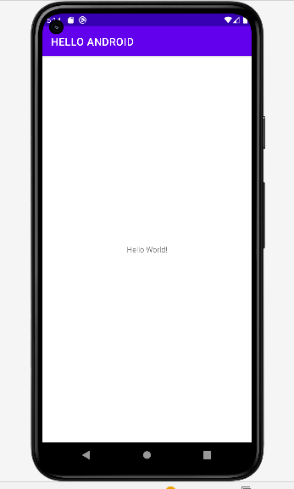

**Practical: Develop app to demonstrate activity life cycle events.**

**File: activity_main.xml**

**<?xml** version="1.0" encoding="utf-8"**?>**

**<android.support.constraint.ConstraintLayout** xmlns:android="http://schemas.android.com/apk/res/android"

    xmlns:app="http://schemas.android.com/apk/res-auto"

    xmlns:tools="http://schemas.android.com/tools"

    android:layout_width="match_parent"

    android:layout_height="match_parent"

    tools:context="example.javatpoint.com.activitylifecycle.MainActivity"**>**

**<TextView**

        android:layout_width="wrap_content"

        android:layout_height="wrap_content"

        android:text="Hello World!"

        app:layout_constraintBottom_toBottomOf="parent"

        app:layout_constraintLeft_toLeftOf="parent"

        app:layout_constraintRight_toRightOf="parent"

        app:layout_constraintTop_toTopOf="parent" **/>**

**</android.support.constraint.ConstraintLayout>**

**File: MainActivity.java**

**package** example.javatpoint.com.activitylifecycle;

**import** android.app.Activity;

**import** android.os.Bundle;

**import** android.util.Log;

**public** **class** MainActivity **extends** Activity {

    @Override

**protected** **void** onCreate(Bundle savedInstanceState) {

**super**.onCreate(savedInstanceState);

        setContentView(R.layout.activity_main);

        Log.d("lifecycle","onCreate invoked");

    }

    @Override

**protected** **void** onStart() {

**super**.onStart();

        Log.d("lifecycle","onStart invoked");

    }

    @Override

**protected** **void** onResume() {

**super**.onResume();

        Log.d("lifecycle","onResume invoked");

    }

    @Override

**protected** **void** onPause() {

**super**.onPause();

        Log.d("lifecycle","onPause invoked");

    }

    @Override

**protected** **void** onStop() {

**super**.onStop();

        Log.d("lifecycle","onStop invoked");

    }

    @Override

**protected** **void** onRestart() {

**super**.onRestart();

        Log.d("lifecycle","onRestart invoked");

    }

    @Override

**protected** **void** onDestroy() {

**super**.onDestroy();

        Log.d("lifecycle","onDestroy invoked");

    }

}

**OUTPUT :**

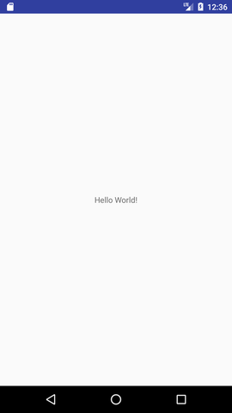

**Practical 4: Develop an app to demonstrate use of toast and snack bar message .**

**File :** **Activity_main.xml**

<?xml version="1.0" encoding="utf-8"?>

<RelativeLayout xmlns:android="https://schemas.android.com/apk/res/android"

xmlns:app="https://schemas.android.com/apk/res-auto"

xmlns:tools="https://schemas.android.com/tools"

android:layout_width="match_parent"

android:layout_height="match_parent"

android:paddingBottom="@dimen/activity_vertical_margin"

android:paddingLeft="@dimen/activity_horizontal_margin"

android:paddingRight="@dimen/activity_horizontal_margin"

android:paddingTop="@dimen/activity_vertical_margin"

app:layout_behavior="@string/appbar_scrolling_view_behavior"

tools:context="com.journaldev.snackbar.MainActivity"

tools:showIn="@layout/activity_main">

<Button

android:layout_width="wrap_content"

android:layout_height="wrap_content"

android:text="DEFAULT SNACKBAR"

android:id="@+id/button"

android:layout_alignParentTop="true"

android:layout_centerHorizontal="true" />

<Button

android:layout_width="wrap_content"

android:layout_height="wrap_content"

android:text="ACTION CALL SNACKBAR"

android:id="@+id/button2"

android:layout_below="@+id/button"

android:layout_centerHorizontal="true" />

<Button

android:layout_width="wrap_content"

android:layout_height="wrap_content"

android:text="CUSTOM VIEW SNACKBAR"

android:id="@+id/button3"

android:layout_below="@+id/button2"

android:layout_centerHorizontal="true" />

</RelativeLayout>

two.setOnClickListener(new View.OnClickListener() {

@Override

public void onClick(View v) {

Snackbar snackbar = Snackbar

.make(coordinatorLayout, "Message is deleted", Snackbar.LENGTH_LONG)

.setAction("UNDO", new View.OnClickListener() {

@Override

public void onClick(View view) {

Snackbar snackbar1 = Snackbar.make(coordinatorLayout, "Message is restored!", Snackbar.LENGTH_SHORT);

snackbar1.show();

}

});

snackbar.show();

}

});

three.setOnClickListener(new View.OnClickListener() {

@Override

public void onClick(View v) {

Snackbar snackbar = Snackbar

.make(coordinatorLayout, "Try again!", Snackbar.LENGTH_LONG)

.setAction("RETRY", new View.OnClickListener() {

@Override

public void onClick(View view) {

}

});

snackbar.setActionTextColor(Color.RED);

View sbView = snackbar.getView();

TextView textView = (TextView) sbView.findViewById(android.support.design.R.id.snackbar_text);

textView.setTextColor(Color.YELLOW);

snackbar.show();

}

});

**File : MainActivity.java**

package com.journaldev.snackbar;

import android.graphics.Color;

import android.os.Bundle;

import android.support.design.widget.CoordinatorLayout;

import android.support.design.widget.FloatingActionButton;

import android.support.design.widget.Snackbar;

import android.support.v7.app.AppCompatActivity;

import android.support.v7.widget.Toolbar;

import android.view.View;

import android.view.Menu;

import android.view.MenuItem;

import android.widget.Button;

import android.widget.TextView;

public class MainActivity extends AppCompatActivity {

CoordinatorLayout coordinatorLayout;

private Button one, two, three;

@Override

protected void onCreate(Bundle savedInstanceState) {

super.onCreate(savedInstanceState);

setContentView(R.layout.activity_main);

Toolbar toolbar = (Toolbar) findViewById(R.id.toolbar);

setSupportActionBar(toolbar);

FloatingActionButton fab = (FloatingActionButton) findViewById(R.id.fab);

fab.setOnClickListener(new View.OnClickListener() {

@Override

public void onClick(View view) {

Snackbar.make(view, "FloatingActionButton is clicked", Snackbar.LENGTH_LONG)

.setAction("Action", null).show();

}

});

coordinatorLayout = (CoordinatorLayout) findViewById(R.id.coordinatorLayout);

View layout= findViewById(R.id.layout);

one=(Button)layout.findViewById(R.id.button);

two=(Button)layout.findViewById(R.id.button2);

three=(Button)layout.findViewById(R.id.button3);

one.setOnClickListener(new View.OnClickListener() {

@Override

public void onClick(View v) {

Snackbar snackbar = Snackbar

.make(coordinatorLayout, "www.journaldev.com", Snackbar.LENGTH_LONG);

snackbar.show();

}

});

two.setOnClickListener(new View.OnClickListener() {

@Override

public void onClick(View v) {

Snackbar snackbar = Snackbar

.make(coordinatorLayout, "Message is deleted", Snackbar.LENGTH_LONG)

.setAction("UNDO", new View.OnClickListener() {

@Override

public void onClick(View view) {

Snackbar snackbar1 = Snackbar.make(coordinatorLayout, "Message is restored!", Snackbar.LENGTH_SHORT);

snackbar1.show();

}

});

snackbar.show();

}

});

three.setOnClickListener(new View.OnClickListener() {

@Override

public void onClick(View v) {

Snackbar snackbar = Snackbar

.make(coordinatorLayout, "Try again!", Snackbar.LENGTH_LONG)

.setAction("RETRY", new View.OnClickListener() {

@Override

public void onClick(View view) {

}

});

snackbar.setActionTextColor(Color.RED);

View sbView = snackbar.getView();

TextView textView = (TextView) sbView.findViewById(android.support.design.R.id.snackbar_text);

textView.setTextColor(Color.YELLOW);

snackbar.show();

}

});

}

@Override

public boolean onCreateOptionsMenu(Menu menu) {

// Inflate the menu; this adds items to the action bar if it is present.

getMenuInflater().inflate(R.menu.menu_main, menu);

return true;

}

@Override

public boolean onOptionsItemSelected(MenuItem item) {

// Handle action bar item clicks here. The action bar will

// automatically handle clicks on the Home/Up button, so long

// as you specify a parent activity in AndroidManifest.xml.

int id = item.getItemId();

//noinspection SimplifiableIfStatement

if (id == R.id.action_settings) {

return true;

}

return super.onOptionsItemSelected(item);

}

}

**OUTPUT:**



**Practical: Develop app to demonstrate use of intents in android.**

**File: activity_main.xml**

**<?xml** version="1.0" encoding="utf-8"**?>**

**<android.support.constraint.ConstraintLayout** xmlns:android="http://schemas.android.com/apk/res/android"

    xmlns:app="http://schemas.android.com/apk/res-auto"

    xmlns:tools="http://schemas.android.com/tools"

    android:layout_width="match_parent"

   android:layout_height="match_parent"

    tools:context="example.javatpoint.com.implicitintent.MainActivity"**>**

**<EditText**

        android:id="@+id/editText"

        android:layout_width="wrap_content"

        android:layout_height="wrap_content"

        android:layout_marginEnd="8dp"

        android:layout_marginStart="8dp"

        android:layout_marginTop="60dp"

        android:ems="10"

        app:layout_constraintEnd_toEndOf="parent"

        app:layout_constraintHorizontal_bias="0.575"

        app:layout_constraintStart_toStartOf="parent"

        app:layout_constraintTop_toTopOf="parent" **/>**

**<Button**

        android:id="@+id/button"

        android:layout_width="wrap_content"

        android:layout_height="wrap_content"

        android:layout_marginRight="8dp"

        android:layout_marginLeft="156dp"

        android:layout_marginTop="172dp"

        android:text="Visit"

        app:layout_constraintEnd_toEndOf="parent"

        app:layout_constraintHorizontal_bias="0.0"

        app:layout_constraintStart_toStartOf="parent"

        app:layout_constraintTop_toBottomOf="@+id/editText" **/>**

**</android.support.constraint.ConstraintLayout>**

**File: MainActivity.java**

**package** example.javatpoint.com.implicitintent;

**import** android.content.Intent;

**import** android.net.Uri;

**import** android.support.v7.app.AppCompatActivity;

**import** android.os.Bundle;

**import** android.view.View;

**import** android.widget.Button;

**import** android.widget.EditText;

**public** **class** MainActivity **extends** AppCompatActivity {

    Button button;

    EditText editText;

    @Override

**protected** **void** onCreate(Bundle savedInstanceState) {

**super**.onCreate(savedInstanceState);

        setContentView(R.layout.activity_main);

        button = findViewById(R.id.button);

        editText =  findViewById(R.id.editText);

        button.setOnClickListener(**new** View.OnClickListener() {

            @Override

**public** **void** onClick(View view) {

                String url=editText.getText().toString();

                Intent intent=**new** Intent(Intent.ACTION_VIEW, Uri.parse(url));

                startActivity(intent);

            }

        });

    }

}

**OUTPUT:**

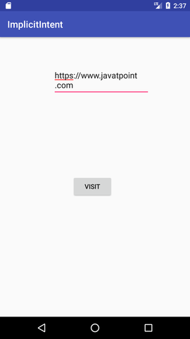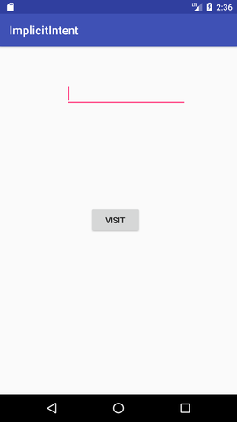

**Practical 6: Develop an application that uses GUI components fonts colours**

**activity_main.xml**

<?xml version="1.0" encoding="utf-8"?>

<RelativeLayout

   xmlns:android="http://schemas.android.com/apk/res/android"

   xmlns:tools="http://schemas.android.com/tools"

   android:layout_width="match_parent"

   android:layout_height="match_parent"

   tools:context=".MainActivity">

   <TextView

      android:id="@+id/textView1"

      android:layout_width="wrap_content"

      android:layout_height="wrap_content"

      android:text="My color is Blue"

      android:layout_centerInParent="true"

      android:textStyle="bold"

      android:textSize="36sp"/>

   <TextView

      android:id="@+id/textView2"

      android:layout_width="wrap_content"

      android:layout_height="wrap_content"

      android:layout_below="@id/textView1"

      android:layout_marginBottom="10dp"

      android:text="My color is Green"

      android:textStyle="bold"

      android:layout_centerInParent="true"

      android:textSize="36sp" />

</RelativeLayout>

**MainActivity.java**

import android.graphics.Color;

import android.support.v7.app.AppCompatActivity;

import android.os.Bundle;

import android.widget.TextView;

public class MainActivity extends AppCompatActivity {

   @Override

   protected void onCreate(Bundle savedInstanceState) {

      super.onCreate(savedInstanceState);

      setContentView(R.layout.activity_main);

      TextView textView1 = findViewById(R.id.textView1);

      textView1.setTextColor(Color.BLUE);

      TextView textView2 = findViewById(R.id.textView2);

      textView2.setTextColor(Color.parseColor("#006400"));

   }

}

**androidManifest.xml**

<?xml version="1.0" encoding="utf-8"?>

<manifest xmlns:android="http://schemas.android.com/apk/res/android" package="app.com.sample">

   <application

      android:allowBackup="true"

      android:icon="@mipmap/ic_launcher"

      android:label="@string/app_name"

      android:roundIcon="@mipmap/ic_launcher_round"

      android:supportsRtl="true"

      android:theme="@style/AppTheme">

      <activity android:name=".MainActivity">

         <intent-filter>

            <action android:name="android.intent.action.MAIN" />

            <category android:name="android.intent.category.LAUNCHER" />

         </intent-filter>

      </activity>

   </application>

</manifest>

**OUTPUT:**

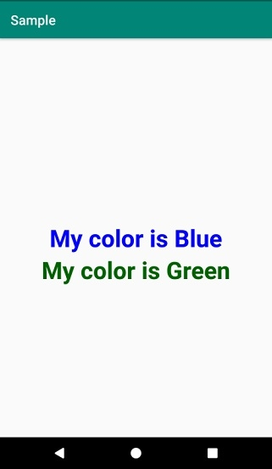

**Practical 7: Develop app to demonstrate use of Radio buttons.**

**activity_main.xml**

<?xml version="1.0" encoding="utf-8"?>  
<RelativeLayout xmlns:android="http://schemas.android.com/apk/res/android"  
    android:layout_width="match_parent" android:layout_height="match_parent">  
    <TextView  
        android:layout_width="wrap_content"  
        android:layout_height="wrap_content"  
        android:layout_marginTop="150dp"  
        android:layout_marginLeft="100dp"  
        android:textSize="18dp"  
        android:text="Select Your Course"  
        android:textStyle="bold"  
        android:id="@+id/txtView"/>  
<RadioGroup  
    android:layout_width="match_parent"  
    android:layout_height="wrap_content"  
    android:orientation="vertical"  
    android:id="@+id/rdGroup"  
    android:layout_below="@+id/txtView">  
    <RadioButton  
        android:id="@+id/rdbJava"  
        android:layout_width="wrap_content"  
        android:layout_height="wrap_content"  
        android:padding="10dp"  
        android:layout_marginLeft="100dp"  
        android:text="Java"  
        android:onClick="onRadioButtonClicked"/>  
    <RadioButton  
        android:id="@+id/rdbPython"  
        android:layout_width="wrap_content"  
        android:layout_height="wrap_content"  
        android:padding="10dp"  
        android:layout_marginLeft="100dp"  
        android:text="Python"  
        android:onClick="onRadioButtonClicked"/>  
    <RadioButton  
        android:id="@+id/rdbAndroid"  
        android:layout_width="wrap_content"  
        android:layout_height="wrap_content"  
        android:padding="10dp"  
        android:layout_marginLeft="100dp"  
        android:text="Android"  
        android:onClick="onRadioButtonClicked"/>  
    <RadioButton  
        android:id="@+id/rdbAngular"  
        android:layout_width="wrap_content"  
        android:layout_height="wrap_content"  
        android:padding="10dp"  
        android:layout_marginLeft="100dp"  
        android:text="AngularJS"  
        android:onClick="onRadioButtonClicked"/>  
</RadioGroup>  
    <Button  
        android:id="@+id/getBtn"  
        android:layout_width="wrap_content"  
        android:layout_height="wrap_content"  
        android:layout_marginLeft="100dp"  
        android:layout_below="@+id/rdGroup"  
        android:text="Get Course" />  
</RelativeLayout>

## MainActivity.java

package com.tutlane.radiobuttonexample;  
import android.support.v7.app.AppCompatActivity;  
import android.os.Bundle;  
import android.view.View;  
import android.widget.Button;  
import android.widget.RadioButton;  
import android.widget.Toast;  
  
public class MainActivity extends AppCompatActivity {  
    RadioButton android, java, angular, python;  
    @Override  
    protected void onCreate(Bundle savedInstanceState) {  
        super.onCreate(savedInstanceState);  
        setContentView(R.layout.activity_main);  
        android = (RadioButton)findViewById(R.id.rdbAndroid);  
        angular = (RadioButton)findViewById(R.id.rdbAngular);  
        java = (RadioButton)findViewById(R.id.rdbJava);  
        python = (RadioButton)findViewById(R.id.rdbPython);  
        Button btn = (Button)findViewById(R.id.getBtn);  
        btn.setOnClickListener(new View.OnClickListener() {  
            @Override  
            public void onClick(View v) {  
                String result = "Selected Course: ";  
                result+= (android.isChecked())?"Android":(angular.isChecked())?"AngularJS":(java.isChecked())?"Java":(python.isChecked())?"Python":"";  
                Toast.makeText(getApplicationContext(), result, Toast.LENGTH_SHORT).show();  
            }  
        });  
    }  
    public void onRadioButtonClicked(View view) {  
        boolean checked = ((RadioButton) view).isChecked();  
        String str="";  
        // Check which radio button was clicked  
        switch(view.getId()) {  
            case R.id.rdbAndroid:  
                if(checked)  
                str = "Android Selected";  
                break;  
            case R.id.rdbAngular:  
                if(checked)  
                str = "AngularJS Selected";  
                break;  
            case R.id.rdbJava:  
                if(checked)  
                str = "Java Selected";  
                break;  
            case R.id.rdbPython:  
                if(checked)  
                str = "Python Selected";  
                break;  
        }  
        Toast.makeText(getApplicationContext(), str, Toast.LENGTH_SHORT).show();  
    }  
}

**OUTPUT:**



**Practical 8: Develop app that as following input boxes:**

**User name, password and a Submit button.**

**On clicking the Submit button, print all the data below the submit button**

**MainActivity.java**.

package com.example.sairamkrishna.myapplication;

import android.app.Activity;

import android.graphics.Color;

import android.os.Bundle;

import android.view.View;

import android.widget.Button;

import android.widget.EditText;

import android.widget.TextView;

import android.widget.Toast;

public class MainActivity extends Activity {

Button b1,b2;

EditText ed1,ed2;

TextView tx1;

int counter = 3;

@Override

protected void onCreate(Bundle savedInstanceState) {

super.onCreate(savedInstanceState);

setContentView(R.layout.activity_main);

b1 = (Button)findViewById(R.id.button);

ed1 = (EditText)findViewById(R.id.editText);

ed2 = (EditText)findViewById(R.id.editText2);

b2 = (Button)findViewById(R.id.button2);

tx1 = (TextView)findViewById(R.id.textView3);

tx1.setVisibility(View.GONE);

b1.setOnClickListener(new View.OnClickListener() {

@Override

public void onClick(View v) {

if(ed1.getText().toString().equals("admin") &&

ed2.getText().toString().equals("admin")) {

Toast.makeText(getApplicationContext(),

"Redirecting...",Toast.LENGTH_SHORT).show();

}else{

Toast.makeText(getApplicationContext(), "Wrong

Credentials",Toast.LENGTH_SHORT).show();

tx1.setVisibility(View.VISIBLE);

tx1.setBackgroundColor(Color.RED);

counter--;

tx1.setText(Integer.toString(counter));

if (counter == 0) {

b1.setEnabled(false);

}

}

}

});

b2.setOnClickListener(new View.OnClickListener() {

@Override

public void onClick(View v) {

finish();

}

});

}

}

**activity_main.xml**.

*In the following code****abc****indicates about logo of tutorialspoint.com*

<?xml version = "1.0" encoding = "utf-8"?>

<RelativeLayout xmlns:android = "http://schemas.android.com/apk/res/android"

xmlns:tools = "http://schemas.android.com/tools" android:layout_width="match_parent"

android:layout_height = "match_parent" android:paddingLeft= "@dimen/activity_horizontal_margin"

android:paddingRight = "@dimen/activity_horizontal_margin"

android:paddingTop = "@dimen/activity_vertical_margin"

android:paddingBottom = "@dimen/activity_vertical_margin" tools:context = ".MainActivity">

<TextView android:text = "Login" android:layout_width="wrap_content"

android:layout_height = "wrap_content"

android:id = "@+id/textview"

android:textSize = "35dp"

android:layout_alignParentTop = "true"

android:layout_centerHorizontal = "true" />

<TextView

android:layout_width = "wrap_content"

android:layout_height = "wrap_content"

android:text = "Tutorials point"

android:id = "@+id/textView"

android:layout_below = "@+id/textview"

android:layout_centerHorizontal = "true"

android:textColor = "#ff7aff24"

android:textSize = "35dp" />

<EditText

android:layout_width = "wrap_content"

android:layout_height = "wrap_content"

android:id = "@+id/editText"

android:hint = "Enter Name"

android:focusable = "true"

android:textColorHighlight = "#ff7eff15"

android:textColorHint = "#ffff25e6"

android:layout_marginTop = "46dp"

android:layout_below = "@+id/imageView"

android:layout_alignParentLeft = "true"

android:layout_alignParentStart = "true"

android:layout_alignParentRight = "true"

android:layout_alignParentEnd = "true" />

<ImageView

android:layout_width="wrap_content"

android:layout_height="wrap_content"

android:id="@+id/imageView"

android:src="@drawable/abc"

android:layout_below="@+id/textView"

android:layout_centerHorizontal="true" />

<EditText

android:layout_width="wrap_content"

android:layout_height="wrap_content"

android:inputType="textPassword"

android:ems="10"

android:id="@+id/editText2"

android:layout_below="@+id/editText"

android:layout_alignParentLeft="true"

android:layout_alignParentStart="true"

android:layout_alignRight="@+id/editText"

android:layout_alignEnd="@+id/editText"

android:textColorHint="#ffff299f"

android:hint="Password" />

<TextView

android:layout_width="wrap_content"

android:layout_height="wrap_content"

android:text="Attempts Left:"

android:id="@+id/textView2"

android:layout_below="@+id/editText2"

android:layout_alignParentLeft="true"

android:layout_alignParentStart="true"

android:textSize="25dp" />

<TextView

android:layout_width="wrap_content"

android:layout_height="wrap_content"

android:text="New Text"

android:id="@+id/textView3"

android:layout_alignTop="@+id/textView2"

android:layout_alignParentRight="true"

android:layout_alignParentEnd="true"

android:layout_alignBottom="@+id/textView2"

android:layout_toEndOf="@+id/textview"

android:textSize="25dp"

android:layout_toRightOf="@+id/textview" />

<Button

android:layout_width="wrap_content"

android:layout_height="wrap_content"

android:text="login"

android:id="@+id/button"

android:layout_alignParentBottom="true"

android:layout_toLeftOf="@+id/textview"

android:layout_toStartOf="@+id/textview" />

<Button

android:layout_width="wrap_content"

android:layout_height="wrap_content"

android:text="Cancel"

android:id="@+id/button2"

android:layout_alignParentBottom="true"

android:layout_toRightOf="@+id/textview"

android:layout_toEndOf="@+id/textview" />

</RelativeLayout>

**string.xml**.

<resources>

<string name="app_name">My Application</string>

</resources>

**OUTPUT**

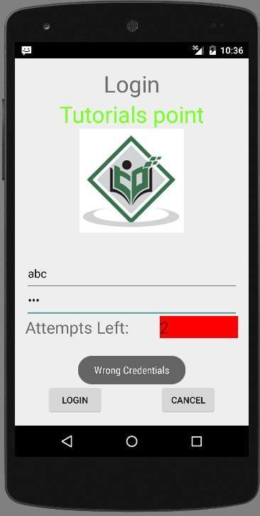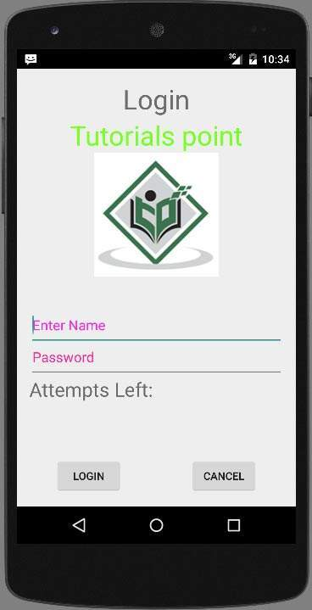

**Practical 9 : Develop app that uses Event Listeners.**

**File :** **Activity_main.xml**

<?xml version="1.0" encoding="utf-8"?>

<RelativeLayout

xmlns:android="http://schemas.android.com/apk/res/android"

xmlns:tools="http://schemas.android.com/tools"

android:layout_width="match_parent"

android:layout_height="match_parent"

android:paddingBottom="@dimen/activity_vertical_margin"

android:paddingLeft="@dimen/activity_horizontal_margin"

android:paddingRight="@dimen/activity_horizontal_margin"

android:paddingTop="@dimen/activity_vertical_margin"

tools:context=".MainActivity">

<TextView

android:id="@+id/textView1"

android:layout_width="wrap_content"

android:layout_height="wrap_content"

android:text="Event Handling "

android:layout_alignParentTop="true"

android:layout_centerHorizontal="true"

android:textSize="30dp"/>

<TextView

android:id="@+id/textView2"

android:layout_width="wrap_content"

android:layout_height="wrap_content"

android:text="Tutorials point "

android:textColor="#ff87ff09"

android:textSize="30dp"

android:layout_above="@+id/imageButton"

android:layout_centerHorizontal="true"

android:layout_marginBottom="40dp" />

<ImageButton

android:layout_width="wrap_content"

android:layout_height="wrap_content"

android:id="@+id/imageButton"

android:src="@drawable/abc"

android:layout_centerVertical="true"

android:layout_centerHorizontal="true" />

<Button

android:layout_width="wrap_content"

android:layout_height="wrap_content"

android:text="Small font"

android:id="@+id/button"

android:layout_below="@+id/imageButton"

android:layout_centerHorizontal="true" />

<Button

android:layout_width="wrap_content"

android:layout_height="wrap_content"

android:text="Large Font"

android:id="@+id/button2"

android:layout_below="@+id/button"

android:layout_alignRight="@+id/button"

android:layout_alignEnd="@+id/button" />

<TextView

android:layout_width="wrap_content"

android:layout_height="wrap_content"

android:text="Hello Samir!"

android:id="@+id/textView"

android:layout_below="@+id/button2"

android:layout_centerHorizontal="true"

android:textSize="25dp" />

</RelativeLayout>

<?xml version="1.0" encoding="utf-8"?>

<resources>

<string name="app_name">myapplication</string>

</resources>

Following is the default content of **AndroidManifest.xml** −

<?xml version="1.0" encoding="utf-8"?>

<manifest xmlns:android="http://schemas.android.com/apk/res/android"

package="com.example.myapplication" >

<application

android:allowBackup="true"

android:icon="@drawable/ic_launcher"

android:label="@string/app_name"

android:theme="@style/AppTheme" >

<activity

android:name="com.example.myapplication.MainActivity"

android:label="@string/app_name" >

<intent-filter>

<action android:name="android.intent.action.MAIN" />

<category android:name="android.intent.category.LAUNCHER" />

</intent-filter>

</activity>

</application>

</manifest>

**File : MainActivity.java**

package com.example.myapplication;

import android.app.ProgressDialog;

import android.os.Bundle;

import android.support.v7.app.ActionBarActivity;

import android.view.View;

import android.widget.Button;

import android.widget.TextView;

public class MainActivity extends ActionBarActivity {

private ProgressDialog progress;

Button b1,b2;

@Override

protected void onCreate(Bundle savedInstanceState) {

super.onCreate(savedInstanceState);

setContentView(R.layout.activity_main);

progress = new ProgressDialog(this);

b1=(Button)findViewById(R.id.button);

b2=(Button)findViewById(R.id.button2);

b1.setOnClickListener(new View.OnClickListener() {

@Override

public void onClick(View v) {

TextView txtView = (TextView) findViewById(R.id.textView);

txtView.setTextSize(25);

}

});

b2.setOnClickListener(new View.OnClickListener() {

@Override

public void onClick(View v) {

TextView txtView = (TextView) findViewById(R.id.textView);

txtView.setTextSize(55);

}

});

}

}

**OUTPUT:**

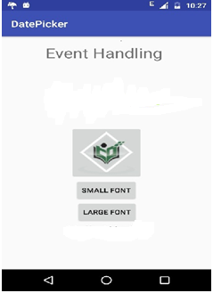

Hello Samir!

**Practical 9: Develop app that uses Layout Managers.**

**MainActivity.java:**

|  |  |
| --- | --- |
|  | package com.example.exno2;    import android.content.Intent;  import android.support.v7.app.AppCompatActivity;  import android.os.Bundle;  import android.view.View;  import android.widget.ArrayAdapter;  import android.widget.Button;  import android.widget.EditText;  import android.widget.Spinner;    public class MainActivity extends AppCompatActivity {        //Defining the Views      EditText e1,e2;      Button bt;      Spinner s;        //Data for populating in Spinner      String [] dept_array={"CSE","ECE","IT","Mech","Civil"};        String name,reg,dept;        @Override      protected void onCreate(Bundle savedInstanceState) {          super.onCreate(savedInstanceState);          setContentView(R.layout.activity_main);            //Referring the Views          e1= (EditText) findViewById(R.id.editText);          e2= (EditText) findViewById(R.id.editText2);            bt= (Button) findViewById(R.id.button);            s= (Spinner) findViewById(R.id.spinner);            //Creating Adapter for Spinner for adapting the data from array to Spinner          ArrayAdapter adapter= new ArrayAdapter(MainActivity.this,android.R.layout  .simple_spinner_item,dept_array);          s.setAdapter(adapter);          //Creating Listener for Button          bt.setOnClickListener(new View.OnClickListener() {              @Override              public void onClick(View v) {                  //Getting the Values from Views(Edittext & Spinner)                  name=e1.getText().toString();                  reg=e2.getText().toString();                  dept=s.getSelectedItem().toString();                    //Intent For Navigating to Second Activity                  Intent i = new Intent(MainActivity.this,SecondActivity.class);                    //For Passing the Values to Second Activity                  i.putExtra("name_key", name);                  i.putExtra("reg_key",reg);                  i.putExtra("dept_key", dept);                    startActivity(i);                }          });      }  } |

**SecondActivity.java:**

|  |  |
| --- | --- |
| **1.pngOUTPUT** | package com.example.exno2;    import android.content.Intent;  import android.support.v7.app.AppCompatActivity;  import android.os.Bundle;  import android.widget.TextView;    public class SecondActivity extends AppCompatActivity {        TextView t1,t2,t3;        String name,reg,dept;        @Override      protected void onCreate(Bundle savedInstanceState) {          super.onCreate(savedInstanceState);          setContentView(R.layout.activity_second);            t1= (TextView) findViewById(R.id.textView1);          t2= (TextView) findViewById(R.id.textView2);          t3= (TextView) findViewById(R.id.textView3);            //Getting the Intent          Intent i = getIntent();     //Getting the Values from First Activity using the Intent received          name=i.getStringExtra("name_key");          reg=i.getStringExtra("reg_key");          dept=i.getStringExtra("dept_key");            //Setting the Values to Intent          t1.setText(name);          t2.setText(reg);          t3.setText(dept);      }  2.png} |